================================================================================ ==============================================

On Hyper-V/Oracle/VMware (whatever your preferred Linux workaround is currently) download Ubuntu image and install it as a virtual machine or WSL2. After this is done:

1. Create a file friends.txt with a list of names of three of your friends on separate lines.

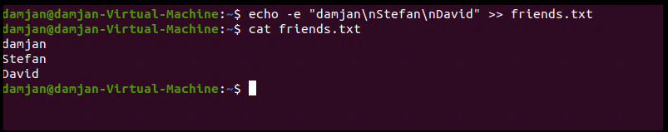

1. Display the contents of friends.txt on the console.   
     
     
   the second command is for the displaying the contents of the text file

1. Rename file friends.txt to bestfriends.txt

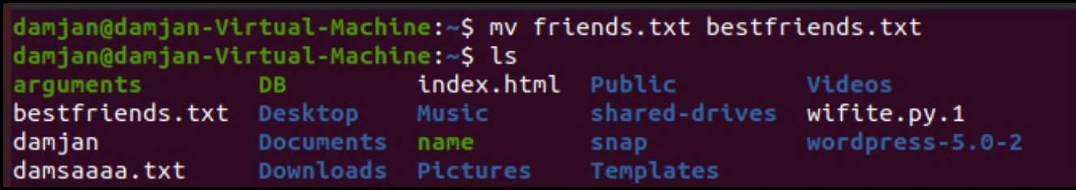

1. Make a copy of bestfriends.txt under the name sysadmins.txt   
     
   

1. List all files whose name begins with letter 'b' and ends with extension txt. 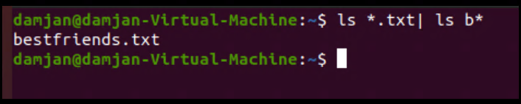
2. rite a command that will tell you how many bytes are taken up by file sysadmins.txt

Exercise: Basic Linux & Bash commands

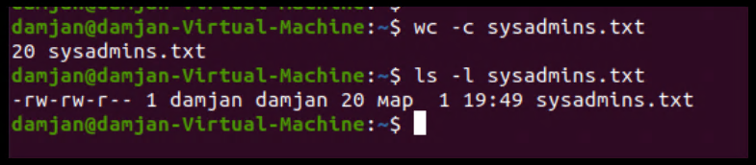

1. Create file cars.txt with a list of 5 brands of cars on separate lines.

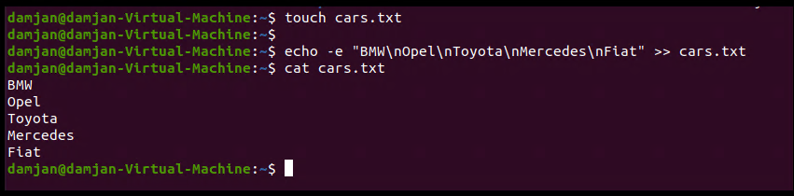

1. Check how many bytes are taken up by the file.

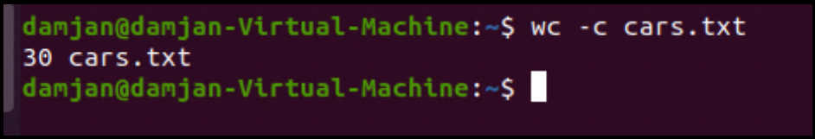

1. Copy the file cars.txt into directory /tmp



1. List all files with extension \*.txt in directory /tmp and verify that the file was copied properly.   
   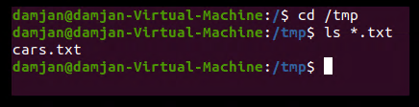

1. Without leaving your home directory rename file cars.txt located in /tmp to vehicles.txt in /tmp   
     
   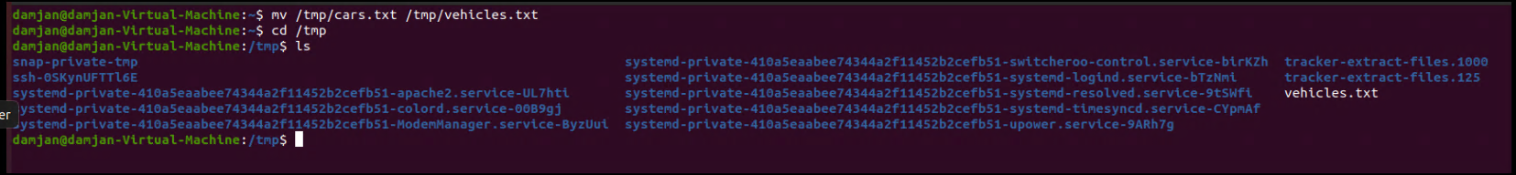

1. Display the contents of /etc/passwd file on the screen interactively (so you can search, scroll up and down)

